4 weeks

After 8 weeks, survival rates between treatments differed significantly (χ2= 18.16, df = 7, p-value < 0.05). The kelp dietary treatment tanks had the lowest survival rates with (mean ± se) 66.44 ± 9.87% and 49.01 ± 9.91% for the ambient and warm temperature treatments respectively. (\*Maybe add reason for low ulva survival rates at week 8?).

After 9 weeks, the kelp dietary treatment animals also had the lowest GSI (mean ± se) 3.02 ± 0.52% and 3.49 ± 0.69% for the ambient and warm temperature treatments respectively, with some urchins having no gonad at all. The kelp dietary treatment was thus suspended after week 9 due to animal ethics concerns. All kelp dietary treatment urchins were removed from the experiment and euthanized. After 24 weeks, the final survival rates between the remaining treatments were similar (χ2= 9.95, df = 5, p-value > 0.05).

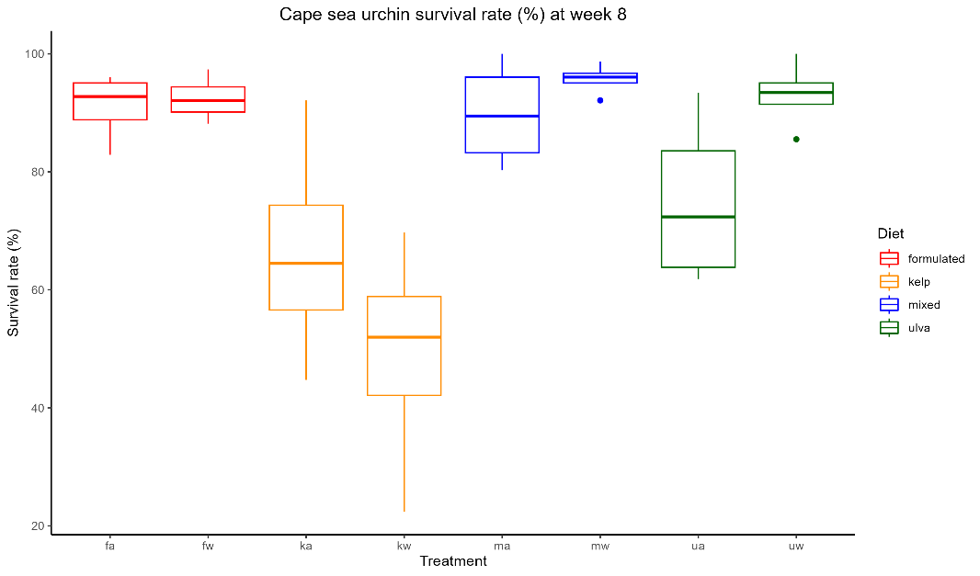

ab

ab

ab

ac

b

bd

c

acd

*Somatic growth*

After 4 weeks, the experimental treatments did not have a significant effect on the specific growth rate (SGR) (%) of the urchin test diameter (SGRdiameter) (χ2= 12.614, df = 7, p-value > 0.05). However, the provision of different dietary treatments had a significant impact on the SGR of the wet weight of the whole urchin (SGRweight) (%) (F = 38.23, df = 3, p < 0.001). The formulated dietary treatment had the highest SGRweight (mean ± se) of 0.23 ± 0.03 % and 0.20 ± 0.02 % for the ambient and warm temperature treatments respectively. The kelp dietary treatment urchins had the lowest SGRweight (mean ± se) of -0.03 ± 0.03 % and -0.10 ± 0.04% for the ambient and warm temperature treatments respectively, indicating that on average the urchins fed kelp (*Ecklonia maxima)* had lost weight over the first 4 weeks of the experiment. The mixed and ulva dietary treatments had similar SGRweight after 4 weeks (Tukey HSD, p > 0.05).

(\*Discuss week 8, was there a significant increase in SGR for the kelp animals?).

*GSI*

The provision of different dietary treatments had a significant effect on gonadal somatic index (GSI) of the urchins (GSI9: χ2= 31.198, df = 3, p-value < 0.001, GSI19: F = 48.397, df = 2, p-value < 0.001; GSI26: F = 125.708, df = 2, p-value < 0.001). The temperature treatment factor did not have a significant impact on the gonadal somatic index (GSI) (%) (GSI9: χ2= 0.132, df = 1, p-value > 0.05; GSI19: F = 0.516, df = 1, p-value > 0.05; GSI26: F = 0.474, df = 1, p-value > 0.05). After 26 weeks, an interaction was present for the temperature and dietary treatments effect on GSI (F = 4.917, df = 2, p < 0.05).

After 9 weeks, urchins fed the kelp and ulva dietary treatments had significantly lower GSI’s than the formulated dietary treatment. Thereafter, all dietary treatments had significantly different GSI’s.

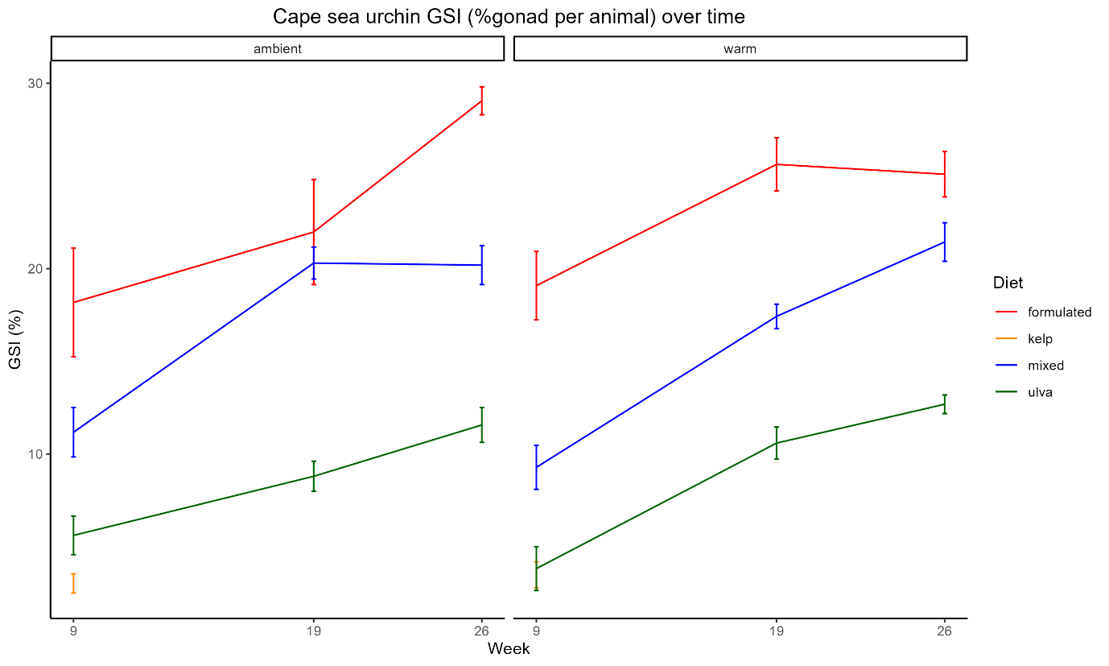

a

ab

bc

c